COMP 360 — Homework 4

Jeff Epstein October 8, 2016

Fabien Bessez

**Questions**

**1. The diagram shows messaging events between three machines. Give the state of the given machine’s vector clock at points a through e. Each point corresponds to time between message events. Assume that all vector clocks starts at (0, 0, 0).** 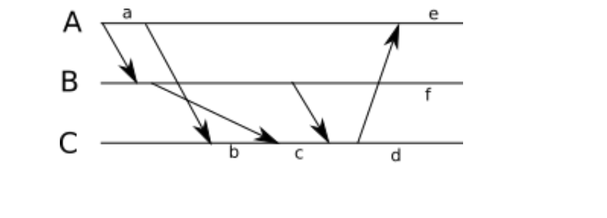

The vector clocks:  
a: (1,0,0); b: (2, 0, 1); c: (2, 1, 2); d: (2, 2, 4) ; e: (3, 2, 4); f: (1, 2, 0)

**2. Consider the following two threads, executed in parallel. Assume that all variables are initialized to 0.**

**Listing 1: Thread 1**

x = 1

y = x + 1

**Listing 2: Thread 2**

y = 4

x = y * 2

**(a) Enumerate all the possible final values of x and y, given arbitrary interleavings of these instructions.**

Let’s assume that “x = 1” is on line 1, “y = x + 1” is on line 2, “y = 4” is on line 3 and “x = y * 2” is on line 4. In that case, there are 6 different combinations of orderings: 1234, 1324, 1342, 3412, 3124, and 3142. In the 1234 ordering, the final values are y = 4 and x = 8. In the 1324 ordering, the final values are y = 2, x = 4. In the 1342 ordering, the final values are x = 8, y = 9. In the 3412 ordering, the final values are x = 1, y = 2. In the 3124 ordering, the final values are x = 4, y = 2. In the 3142 ordering, the final values are x = 8, y = 9.

**(b) Now assume that the above threads are bracketing by locking instructions. That is, thread 1 acquires a lock before its first instruction and releases it after its last instruction; and thread 2 acquires the same lock before its first instruction and releases it after its last instruction. Which possible final results of the execution are possible, if any?**

Assuming that thread 1 and thread 2 have agreed on a protocol for requesting locks in a particular order to avoid deadlocks, then there are two possible final results. Depending on which thread gets access to the locks first, then the final values are x = 1 and y = 2 or x = 8 and y = 4. However, if they happen to request locks in a disorganized way, there is a possibility that thread 1 requests a lock on x while thread 2 requests a lock on y. In this case, both threads will be waiting for the other thread to release their desired lock – resulting in deadlock.

**3. Assume that a read/write lock (also known as a readers/writer lock) always gives access to waiting readers, if the lock is already held by at least one reader. Describe how this policy can lead to starvation.**

In a world where a read/write lock always gives access to waiting readers, if the lock is already held by at least one reader, one could imagine a scenario when there is an un-ending stream of readers for the entirety of the lock’s existence. Since a writer would never be granted ownership of the lock in that scenario, it can be said that that implementation can lead to starvation.

**4. Discuss the factors that affect the performance of a system when considering fine-grained (smaller elements) versus coarse-grained (larger elements) locking.**

When considering whether to implement fine-grained versus coarse-grained locking, it is important to understand the trade-offs in choosing one over the other. In choosing coarse-grained locking, you decrease the availability of the system, because whenever a lock is owned, other requests will have to wait. As a result, deadlocks are less likely. If fine-grained locking is chosen, then availability is increased but so is the likelihood of deadlock. It is important to know how many requesters there might be. If speed of a transaction is a concern, then it seems like a fine-grained locking system would be preferred since there will be less waiting time.